Sports and Activities – Play, Go, Do?

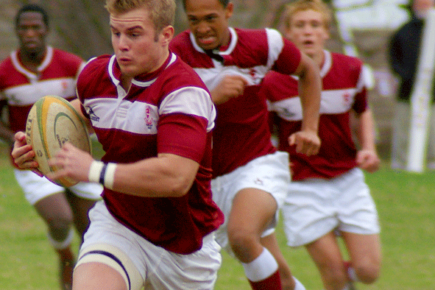

Play: Use com esportes competitivos
(com times) e jogos da tabuleiro.

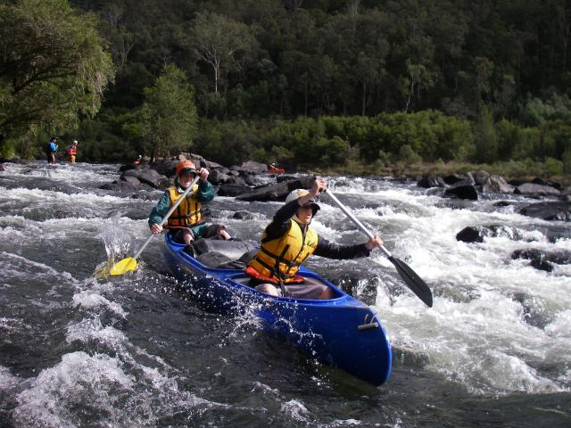
Play Rugby

Go: Use com esportes que envolvam locomoção,
não são feitos em um lugar fixo.

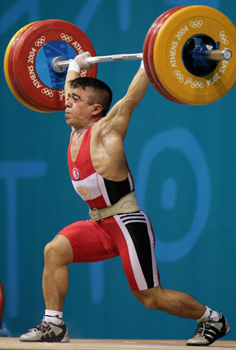
Go Canoeing

Do: Use com esportes que não envolvam locomoção,
são feitos em um lugar fixo.

Do Weight
Lifting

play | go | do
football  basketball  chess  tennis  volleyball  rugby | swimming  running  walking  jogging  sailing  canoeing | gymnastics  aerobics  weight lifting  yoga  training  pilates

Examples:
- I play football every day.
- He plays volleyball every Saturday.
- We go swimming every weekend.
- She goes sailing on Sundays.
- They do yoga on Tuesdays.
- He does pilates twice a week.
- I like to play chess frequently.
- She likes to do gymnastics.
Exercise 1. Play, do or go? Complete as necessary.
1. He _______________ jogging every day.
2. I love to _______________ a game of chess.
3. She _______________ gymnastics on Fridays after school.
4. We _______________ windsurfing on Ipanema beach every Saturday.
5. He _______________ baseball every weekend with his mates.
6. My wife _______________ horse-riding twice a week.
7. Let's _______________ tennis in the park.
8. I want to _______________ sailing tomorrow.
9. I always _______________ soccer on Sundays with my friends.
10. We never _______________ walking in the park.
11. Susan _______________ chess very well.
12. They _______________ rugby at school.
13. John likes to _______________ hockey.
14. Do you want to _______________ basketball with me?
15. I love to _______________ yoga.
16. Emma sometimes _______________ cycling.
17. My son loves to _______________ skateboarding.

Exercise 2. Pronunciation & Vocabulary practise.
archery, badminton, bicycle racing, boxing, car racing, fishing,
gliding, hang-gliding, horse-riding, ice-hockey, ice-skating,
kite-surfing, parachuting, rafting, rollerblading, rowing,
scuba-diving, skateboarding, skiing, snorkelling, snowboarding,
surfing, water-skiing, windsurfing, wrestling

Note: None of these sports use a ball!

Q: Which of these sports would you like to do?
A: I would like to do / go / play ……..

Q: Which of these sports would you never do?
A: I would never do / go / play ……..

